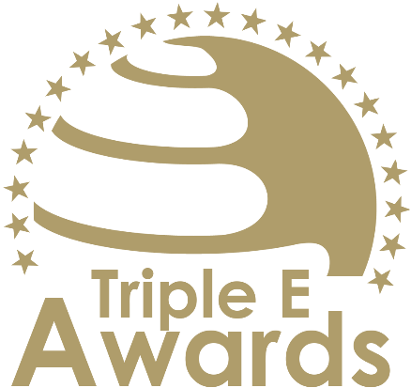

Student-driven Sustainability Project
of the Year
Submission template

About this document

This document shall be used to prepare your entry submission for the Triple E Awards.

Key recommendations:
- Avoid pure “marketing language” but provide a critical evaluation
- Provide clear examples, data and further evidence (note that you can upload up to 10 pictures during the submission of your entry. Please do not copy these pictures into this document!)

Checklist:
[ ] The submission has been prepared in English language
[ ] I responded to all sections of this template
[ ] The section titles and descriptions have been kept
[ ] I deleted the cover page as well as this page
[ ] The submission (after deleting the cover page and this page) does not exceed 3 pages
[ ] The font size and style has been kept and the margins of the documents have not been changed
[ ] I have selected up to 10 pictures (in .jpg or .png format) that can be uploaded together with this document.

How to submit:
- Visit https://asiapacific.triple-e-awards.com/index/apply
- Create an account
- Click on the “Submit your Entry Now” button
- Select the award category you would like to submit your entry to (Step 1)
- Provide submission details and upload this document in PDF format (Step 2)
- Upload up to 10 pictures for your entry (Step 3)
- Click on “Finish submission” (you can view, edit and delete your entry in the entry overview on the submission landing page)
Details of the project
Implementation year of the project
# of students integrated in the project

Relevance of the problem addressed
Present the problem that the student-driven driven sustainability project addressed. Provide data shat shows the relevance of the issue.
[Please put your response here]
Innovativeness of the solution
Present the solution that has been developed to address the before mentioned problem. Highlight specifically the innovativeness of the solution, i.e. how it creates greater benefits compared to existing solutions.
[Please put your response here]
Innovativeness and transferability of the project approach
Present how the project was carried out (e.g. time frame, students profile, partners …) and highlight innovative elements of the (educational) approach. Is the approach taken transferable? If so, in which other settings / situations can it be used.
[Please put your response here]

